Research report

Due 29 November 2024 @2359

**Preamble** 1

**Tasks** 2

(1 mark) When was this library first released? 2

(1 mark) What license was this library released under? 2

(1 mark) How popular is this library? 2

(2 mark) Why does the library exist? 2

(2 marks) Do any alternatives exist? 2

(3 marks) Implement an example from the library 3

**Guidelines** 3

Attribution 3

Generative AI (e.g. ChatGPT) 4

**Criteria** 4

**Submission** 4

# Preamble

The JavaScript ecosystem is filled with plenty of open source libraries. Pick one such library for your main focus and attempt the tasks listed below.

* D3.js
  1. <https://github.com/d3/d3>
* Lodash
  1. <https://github.com/lodash/lodash>
* Chart.js
  1. <https://github.com/chartjs/Chart.js>
* Bootstrap
  1. <https://github.com/twbs/bootstrap>

○ <https://getbootstrap.com/docs/5.3/getting-started/introduction/>

* jQuery
  1. <https://github.com/jquery/jquery>● Pick a library of your choice

○ Have a library in mind that's not listed here? Consult your tutor on whether you may use it for this report.

○ Try to pick one with at least 10k stars on Github

# Tasks

## (1 mark) When was this library first released?

What year was this library created?

## (1 mark) What license was this library released under?

Most libraries have a LICENSE.txt file in their code repository.

## (1 mark) How popular is this library?

How many stars does the project's Github repository have?

Try to find out how many downloads this project gets in a month (or any other timeframe).

## (2 mark) Why does the library exist?

What is the library meant to address/implement?

Does JavaScript natively already support doing what the library does? If it does, why do people prefer to use the library over implementing it using JavaScript's native features?

## (2 marks) Do any alternatives exist?

What are some of the close alternatives that exist which function similarly to your chosen library?

Pick 2 alternatives and compare its features against your chosen library.

If there are no alternatives, why do you suppose no one has made any?

If there are alternatives, why would someone pick this library over its alternatives?

## (3 marks) Implement an example from the library

Most libraries should include examples on how to implement it. Set up an example where you include the library in a HTML file and implement one of its examples.

If the library cannot be used on vanilla HTML/JS (can only be installed with npm), have a short writeup on how you can set up a minimum reproducible starter instead. Ensure your tutor knows in advance if you are doing this.

# Guidelines

## Attribution

If quoting from an external source, you MUST list its reference.

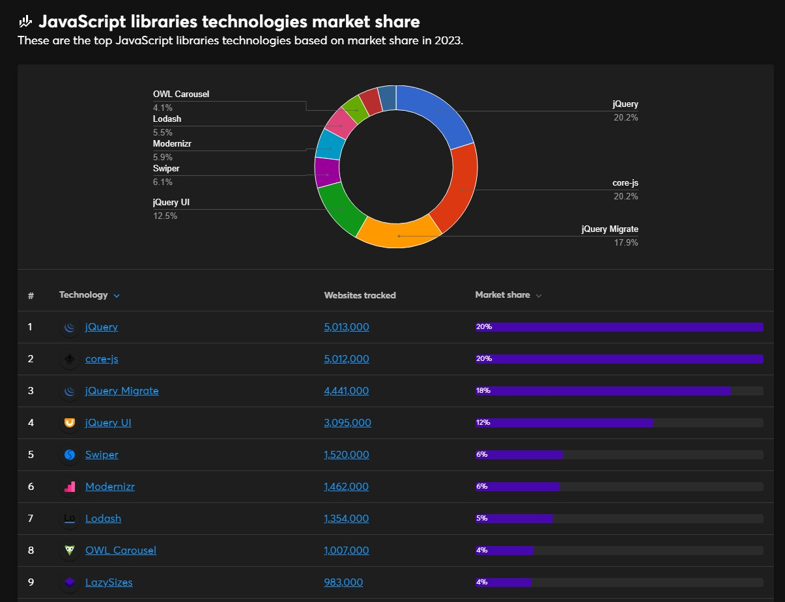

<https://www.wappalyzer.com/technologies/javascript-libraries/>Retrieved 2023-11-06

## Generative AI (e.g. ChatGPT)

1. Gen AI is allowed, such as to generate code snippets for your examples.
2. Avoid using Gen AI to generate the content for the tasks in your report. You may consult Gen AI while doing your research, but do not lift content from it directly.
3. If you've used Gen AI, you MUST state how you have used it in your report.

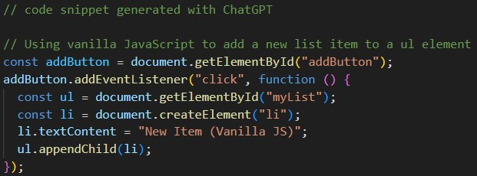

Figure: Attributing a code snippet to ChatGPT

# Criteria

1. Complete all the tasks listed in the brief
2. Adhere to the guidelines listed

# Submission

1. Submit your report as a PDF document
2. Zip up your report, along with any code files you want to attach
3. **Failure to submit within the stipulated deadline will result in a 2 mark deduction for every day exceeded**